Societies Volunteer Guidelines
Logging Volunteer Hours

Am I Societies Volunteer?

A society volunteer is an elected committee member of a Manchester Metropolitan University society. If you are a member of the Societies Council, you are also a volunteer.
In order to begin logging your hours as a societies volunteer you will need to register on the volunteer system by following this link:
https://www.theunionmmu.org/volunteering-opportunities/societies-committee-member

As a Societies volunteer, you can logs hours for:
Planning an event or activity for your society (max 4 hours per day)
This may include:
- Planning meetings (as a committee or with Union staff / venue contacts, etc)
- Sourcing materials
- Sourcing instructors/external speakers
- Budgeting
- Completing a Risk Assessment
- Campaigning

Managing an event (max 6 hours per day)
This may include:
- Registering attendance/selling tickets
- Managing the Risk Assessment during the event
- Managing the schedule during the event
- Managing the close of an event

Committee Training at The Union
This may include:
- Induction training (May / September)
- 1-2-1s with Union staff (please specify staff member in notes)
- Additional training, e.g. Events Training, First Aid, etc

Online training (5 different online modules completed = 1 hour)

Attending Council Meetings or Grants Panels

Leading a Trip (8 hours cap per day including travel)
You must be leading the trip for the hours you log and detail your responsibilities during this time

Promoting your society (6 hours max per day)
This may include:
- Staffing your society stall at Fresher’s/Refreshers’ Fair
- Welcome Warrior activities during Move In Weekend

Being a Societies Council Representative
This may include:
- 1-2-1s with students
- 1-2-1s with Societies and Development Officer
- Grant panels and council meetings
- New Society Decisions (log hours per month)

You are unable to log hours for the following activities:
- Attending an event
- Going to a social / doing regular society activities
- Travelling to an event
You role as a Societies Volunteer can be varied depending on your activity, membership and number of events you hold.
If you are unsure about your activity and if it qualifies as a volunteering hour or you are unsure if you are an elected committee member, please contact the Opportunities Team on s.u.societies@mmu.ac.uk

How to log your hours as a Society Committee Volunteer

How do you start logging your hours:
Once you have been approved on our system it is super simple to start logging your hours. If you do have any questions or queries, you can contact the volunteering service.

Step 1: Log into The Union website

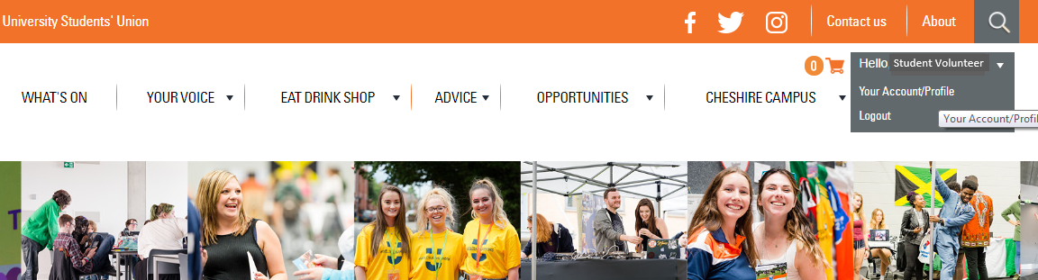
Step 2: Click on your account profile

Step 3: Click on Volunteering on the left hand side
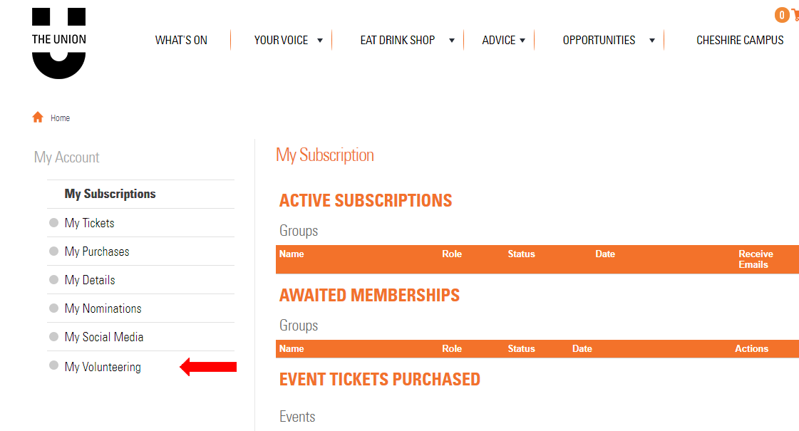

Step 4: Click on Timesheet on the left hand side.

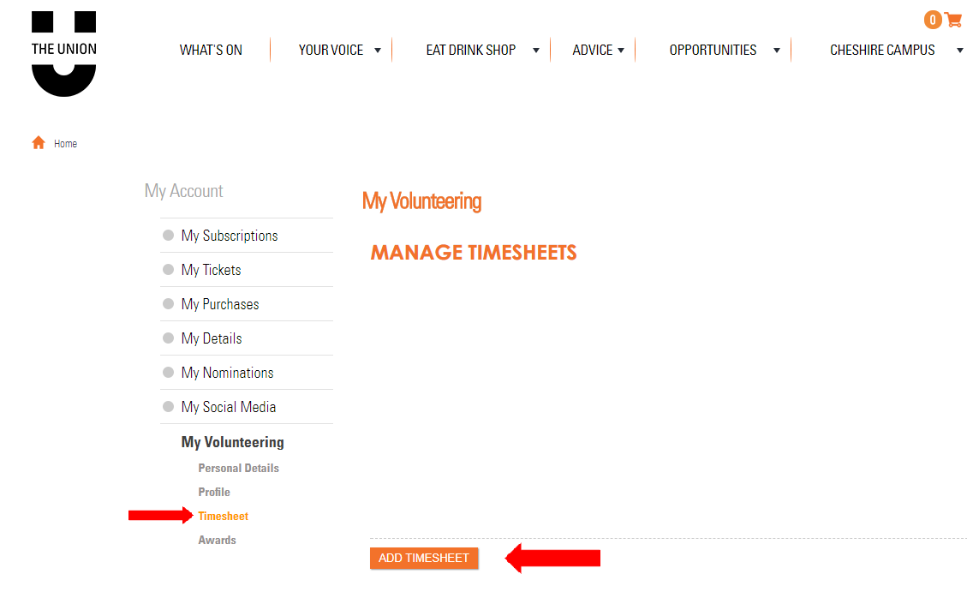
Step 5: Click on ‘ADD TIMESHEET’ in the orange box.

Step 6: Choose your opportunity, from the drop down menu.

Step 7: Input, the date of your volunteering and the hours spent volunteering.
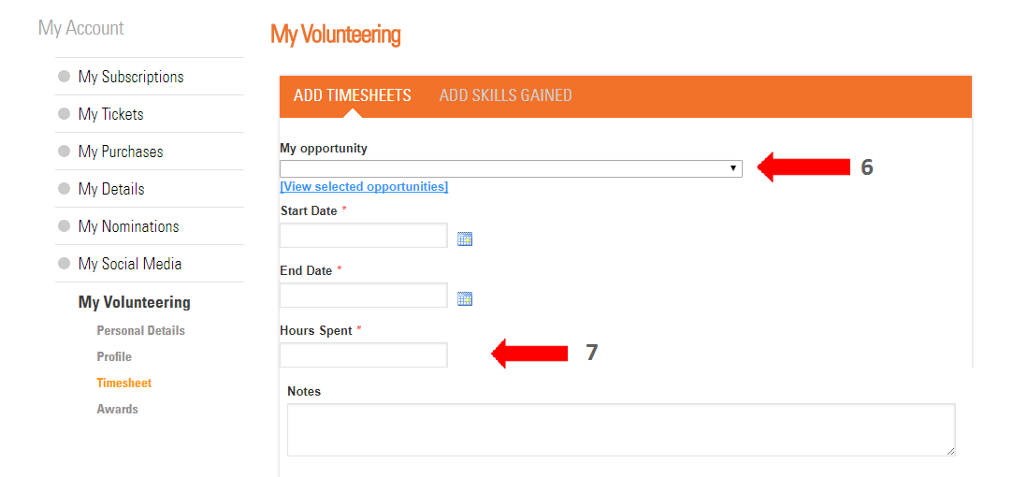

Step 8: Add notes about your role
We would like to know what you are logging hours for. You can add a description in the notes box.
If you are in a society, please write your society in here!
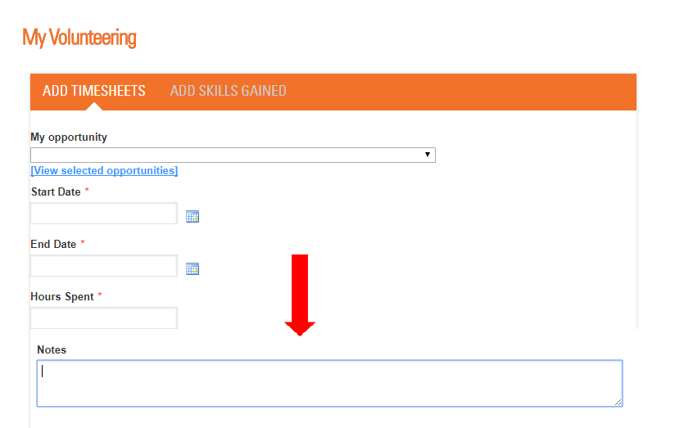

Step 9: Select skills you have gained. You must select a skill; you then have a section where you need to write how you learned this skill. This can be as long or as short as you like. 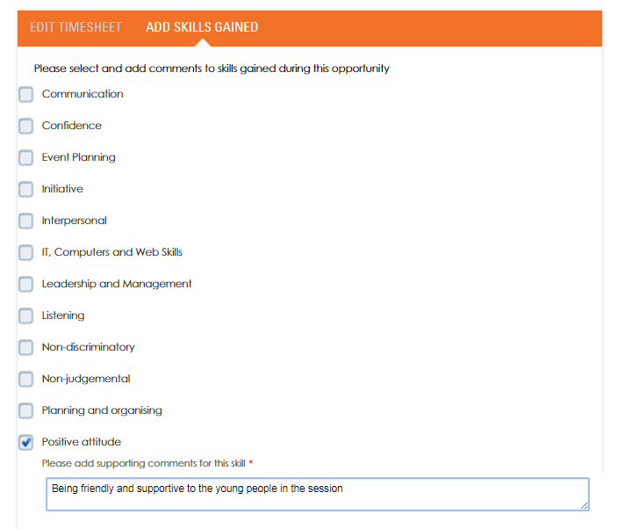

Once you have submitted this form, your hours will be approved your hours.

As you reach the milestones we will send you emails, so you can access your well-earned rewards!
If you have any worries or questions, we are here to help, contact the volunteering service on volunteering@mmu.ac.uk or 01612472211

