

**Online Events**

Handbook



**Contents**

**3** Introduction

**4** Event Planning

**5** Event Promotion

**6** Creating your event on The Union website

**9** Guide to using online platforms

**10** Zoom and Microsoft Teams

**11** Discord and Facebook Live / Instagram Live

**12** WhatsApp and Gaming Apps to play

**13** 101 Event Ideas

* Wellbeing
* Food
* Music
* Art
* Party Vibe
* Educational
* Sport
* For fun and making friends

**Introduction**

**What is this guide?**

This guide is intended as a supporting tool to provide Society Committee members with information about different platforms and ideas for online activities to put on for members of their society.

Several online platforms are focused on in this document but we appreciate that more appear all the time so please let us know if you think there are more which we could focus on and share with the rest of the society family.

**Event Planning**

As when running in-person events always make sure that you have your event well planned out. Make sure you consider a minimum of the following when planning your event:

* Risk Assessment
* Data Protection
* Promotion for your event
* Accessibility to your members
* Cost

We’ll cover these during this online guide.

**Event Planning**

**Cost**

One of the main things to check is if your society has enough money to run the event. If not is there something else you can do similar which you can run. One of the key costs with virtual events is the platform they’re being run on. Some platform have costs if you want premium unlimited versions (such as Zoom) but there are similar alternatives for free (such as Microsoft Teams). Think about what you need for your event and if there is a similar or alternative platform you could use.

If the cost is something else such as the cost of an external speaker, don’t forget you can charge a ticket fee to members to attend the event to cover the cost similar to what you’d do for an in-person event.

We also have a pot of money which you can apply for if you’re struggling with the costs of your event. See the [Committee Resource Hub](https://www.theunionmmu.org/your-voice/committee-resources) for more information.

**Accessibility to your members**

Always make sure you check the accessibility of a platform for your members. If it’s the first time someone has used the platform, is it easy to access? Will attendees need to have a camera or microphone? Will they need two devices or will using a smartphone be sufficient? Is the description clear as to what’s happening during the event or if there’s a certain dress code?

**Risk Assessments**

As with in-person events, risk assessments will be needed for your virtual events. Whilst you may not need to worry about where the fire exits are, you’ll need to consider things like security on the platform you’re using and any capacity limits.

In terms of security the best way to solve this is to make sure the link to your event is not publicly available. We have developed a template risk assessment form to help you assess the risk of your activity which you can access from the resources section of the Unions’ website.

Capacity limits are something to remember when using specific platforms and also thinking about the nature of your event. Some platforms have 100 person limits (inducing any hosts) whilst others can go up to 250. If you’re having a discussion event for example, it might not work as well if you have 250 people on the call than if you limit the event.

**Event Promotion**

**Promote Your Event**

In the current virtual environment, the most efficient way to promote your online event is online. As soon as you know the dates and times for your event and have a link you’ll then be able to add your event onto your society page on The Union website and it will appear on the events page.

There are some key things to remember when you’re planning and promoting your event:

**Get the message out as soon as you can:** Ideally you need to promote your event two weeks before it’s due to take place. This gives people time to see it on social media or on the website and make sure they save the date. The less time you promote it the less likely you’re going to be able to reach out to new members.

**Use multiple platforms to promote your event:** It’s great to promote your event through the website, but don’t just use that as the one way to get the message out. Pop the signup link on your social media and remember to contact members through other ways – such as via email for those who might not have social media. See if you can get it shared by other societies if it’s a collaborative event or by University departments if it’s an academic one.

**Make sure the numbers work:** Similar to considerations with room sizes when booking physical rooms, you’ll need to spare a thought for the platform you’re using, especially if you need specific features. Different platforms allow different numbers of attendees including any host(s). Also think about what would work for your event both for your risk assessments but also for the style of your event. For example if your event is a discussion it probably won’t be as successful if hundreds of people sign up.

**Is your event a one off or a regular session?** When you’re promoting your event remember to be clear whether this is a regular event or a one off. If it happens every Monday for example, make sure people know that tickets will be on sale for the next event and ideally let them know when this is due to happen.

Sometimes it’s clear that the event is a one off, such as if it’s to celebrate a certain national day or event. On your event it’s always useful to include a way for people to find out more of what you’re doing or where they can find updates (such as your social media).

**Creating your event on The Union website**

**How do I add my Event to my society page?**

It’s really simple to add your Event to your society page. First, head over to your

Dashboard controls on the website once you’ve signed in. (If you can’t see an option

for your Dashboard, drop us an [email](mailto:s.u.societies@mmu.ac.uk) and we’ll sort it out for you).

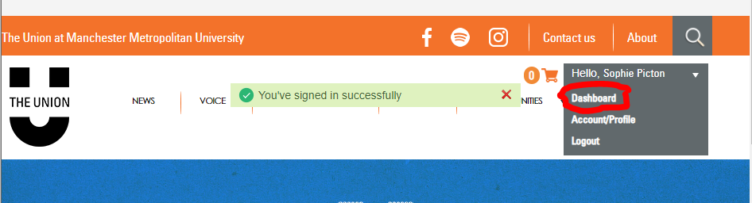

You’ll then see an option to Manage events. Here you can create your events and also manage existing events.

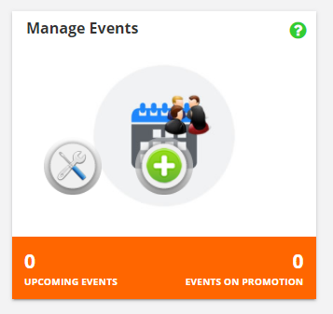

Click the ‘Add Events’ button and you’ll then be able to choose a name for your event, provide a description, logo plus key information such as timings and what platform it’s on. Once you’ve set up your event, drop us an [email](mailto:s.u.societies@mmu.ac.uk) and we’ll add tickets for you.

Once you’ve set your event up it’ll appear on the ‘Society Events’ page on the Events part of the Union website.



**FAQs**

**Can I put the link to our virtual event on the description and not have tickets?**

No. For safety and insurance reasons all virtual events should be ticketed. This is for security so you know who to expect for your events. Not only does it give you a better idea of numbers, it is an extra layer of security for your event as it prevents people who haven’t signed up to the event just turning up unexpectedly.

Having the link in the description means that people can get to event without buying a ticket.

There doesn’t necessarily have to be a cost to that ticket. Free events must still have tickets as there needs to be a way to send people who have registered for the event a link to the event.

**How will I know who has got a ticket and will they have the link to the event?**

You can check who has got a ticket by going into your Dashboard then ‘Manage Events’. All your current events are listed there. Then all you need to do is click on the ‘Show Event’ button as shown below.

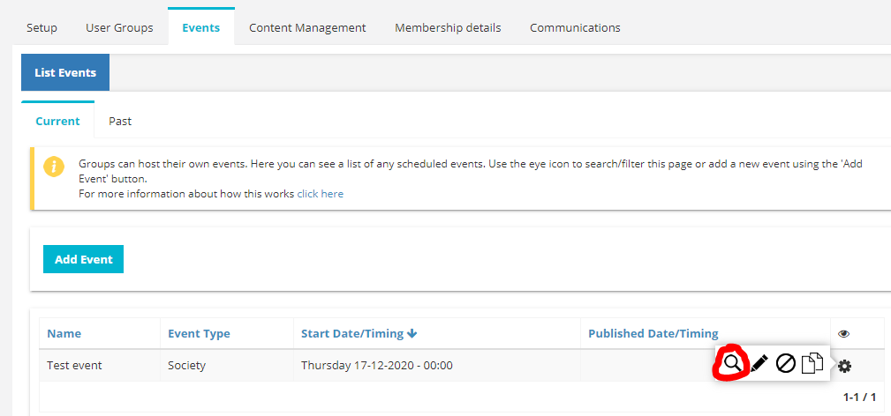

If you then click on booking details you’ll then be able to see who has bought the tickets. When your tickets go off sale you should ‘Download booking details’ which will let you save an Excel document with everyone who has bought a ticket. You can then email them with the link to your event. Please note this is not done automatically so you’ll need to email the link to your event to those who have bought tickets. Please keep GDPR in mind at all times and only keep the personal data until you’ve sent them the link. If you’re emailing all attendees at the same time please remember to bcc when you’re emailing them so the email addresses aren’t shared.

**Does someone have to be a member of the society to buy a ticket?**

That’s up to you. When you ask us to set tickets up you can have multiple tickets on sale. Some societies have tickets for members which are slightly cheaper than those for non-members – this encourages people to buy the membership of the society. If yours is a free membership you may want to do this to ensure it’s a members only event. You can also limit the amount of tickets one person can buy.

**How far in advance do I need to put my event online?**

We recommend having the event up as soon as you know the details as then people will be able to see it for longer. Just consider when you want the tickets to go off sale so you have enough time to send people the link. Also remember to share the link to your event page on your social media.

**I haven’t set the link up or don’t know the times of my event, can I still put it on the website?**

If you don’t have the link yet you can still add your event to the website but you need to know the timings. It’s also a good idea to know at least the platform you’re using even if you don’t know the link yet – that way people know if they have to download an app or similar.

**Can I edit my event once it’s on the website?**

Yes. However, you will need to make sure you communicate any changes to people who have signed up or purchased a ticket.

**How do I set up a re-occurring event?**

Once you’ve set up your event and it has the tickets attached you can copy it and add how frequent it’s going to be (see below). Please let us know if the tickets are going to be different prices for some of the events as we’ll be able to edit this for you.

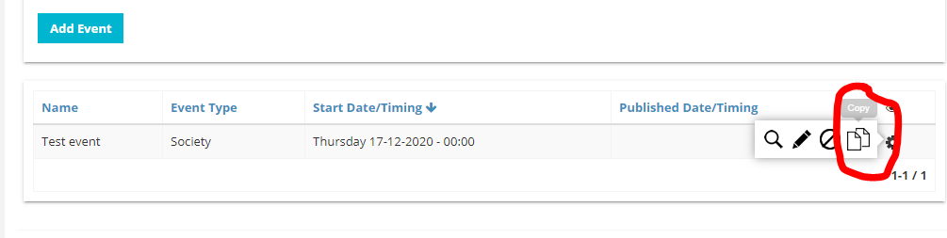

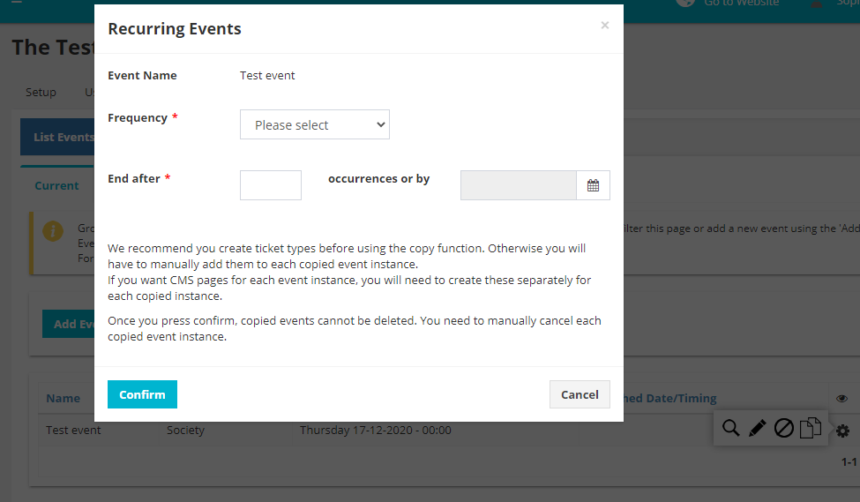

**Guide to using online platforms**

There are lots of different types of online events you can hold for your Society. Here are a few ideas and tips.

Try out:

* + Online games socials.
  + Skills tutorials.
  + Discussion groups about issues, books or films.
  + Sharing creative projects (eg. poems, art..).
  + Live streams.
  + Fundraising activities.
  + Get together on a video call to cook, craft, game, paint or knit together.
  + Music listening sessions.
  + Yoga, mindfulness, pilates or aerobics classes.
  + Quizzes or trivia games.
  + Use things everyone has access to, e.g. grab the household item.
  + Use hashtags to promote your event and create conversation.
  + Avoid alcohol fueled events.
  + …there are many more!
* Share short how-to instructions to help your members join in. You could also do “how to” videos so that people know what to expect if joining for the first time.
* Host activities that encourages everyone to speak and get to know each other
* Use ‘mute’ functions to lessen background noise from everyone on a call
* You may want to create guidelines and share these with participants in online events, particularly where they have access to a ‘chat’ function and may share spam or offensive content. Familiarise yourself with the platform functions before you use it, eg. can you remove people from a chat if they are breaking the guidelines?
* Try to host a variety of events to attract everyone. Use polls or Instagram questions to gauge what your members want.
* Don’t spam people, have regular posts on social media that people can expect. You can also monitor your insights to see how people have interacted with your posts.
* On social media, avoid giving our personal information or giving people nicknames which may be offensive. Remember to be relevant, post in the mindset of your group, and remember to avoid bias or being political.
* Remember you can collaborate with other groups both at MMU and around the world.
* Delegate as a committee so it doesn’t fall on one committee member to organise everything.

**Zoom**

Zoom is a popular video call app. It is possible to download the app or log into a

call online. Within calls you can create breakout rooms, use virtual backgrounds

and much more to make an activity dynamic and fun.

Zoom Support: <https://support.zoom.us/hc/en-us/categories/201146643>

Frequently asked/ getting started: <https://support.zoom.us/hc/en-us/articles/206175806>

How to use Breakout Rooms: <https://support.zoom.us/hc/en-us/articles/206476313#h_1660846b-7d2d-4a87-b8a6-efe29a61759a>

How to schedule a reoccurring meeting: <https://support.zoom.us/hc/en-us/articles/214973206-Scheduling-Recurring-Meetings>

**Microsoft Teams**

All MMU students have access to Microsoft Teams which they can use outside of their studies. Teams allows you to message, call and video call other people in your Team.

More info on Teams and how to download it: <https://www.mmu.ac.uk/isds/support/apps/teams/>

You can access lots of support when using Teams on the Help tab of the desktop app.

**Discord**

Discord is a free app geared towards video game players, but it could be used for any activity!

It provides users with ways to find like-minded people, chat, coordinate gameplay or other activities, and talk while playing. It supports video calls, voice chat, and text.

You can create a ‘server’ for your activities as a society which can contain many different channels.

What is Discord? <https://www.digitaltrends.com/gaming/what-is-discord/>

How to set up and use Discord: <https://youtu.be/E7xznRGg9WM>

**Facebook Live/ Instagram Live**

These platforms allow the account to run a video stream live to those who follow them. Followers can comment on the live video but not also share their video. It works well for Q&As, tutorials and less formal content.

The basics on Facebook Live: <https://www.facebook.com/formedia/solutions/facebook-live>

How-To live stream an event on Facebook: <https://www.facebook.com/business/help/626637251511853?id=1123223941353904>

Things to keep in mind when ‘going live’: <https://www.facebook.com/facebookmedia/blog/tips-to-keep-in-mind-before-during-and-after-you-go-live>

How to use Instagram Stories (scroll down for info on Live Video): [https://help.instagram.com/1660923094227526/?helpref=hc_fnav&bc[0]=Instagram%20Help&bc[1]=Using%20Instagram](https://help.instagram.com/1660923094227526/?helpref=hc_fnav&bc%5b0%5d=Instagram%20Help&bc%5b1%5d=Using%20Instagram)

**WhatsApp**

WhatsApp is a great place to keep a group chat for members of your society.

You can have a chat either as a space for all members to interact or you can use

an ‘announcements only’ WhatsApp where committee members share information

about upcoming events

How to create an announcement only chat: <https://blog.whatsapp.com/new-group-setting-for-admins>

Other features available in group chats: <https://blog.whatsapp.com/new-features-for-groups>

**Gaming Apps to play**

You can use other apps or websites to play games just on their platforms or during your video calls.

Try out:

* **Psych!**: <https://play.google.com/store/apps/details?id=com.wb.goog.ellen.psych&hl=en_GB>
* **Jackbox Games**: <https://www.jackboxgames.com/>
* **Kahoot**: <https://kahoot.com/what-is-kahoot/>
* **Bunch**: <https://bunch.live/>

There’s lots more out there, so get googling!

**101 Event Ideas**

Below is a list of some event ideas that we’ve heard some of you have been already doing and what we’ve heard other societies have been doing around the country.

**Wellbeing**

* Yoga.
* Craftism.
* Religious or spiritual sermon.
* Guided meditation.
* Step count challenge.
* Gardening classes.
* Virtual gardening club.
* Garden tour.
* Pilates.
* Growing competition.

**Food**

* Cook along.
* Coffee tasting.
* Pizza party.
* Dinner party.
* Instagram cooking comp.
* Food bank collection.
* Cultural food exchange.
* Ready steady cook – get a local store to put together food parcels and everyone cooks the stuff together over Instagram then voting for who is the winner.
* Food tasting.

**Music**

* Listening parties. E.g. on twitter at 9pm we’ll all play this specific album and live tweet a reaction to each song. Have a hashtag or something to go by.
* Lip sync battle.
* Open mic night.
* Lessons.
* Pre-record choir/band.
* Live stream an event/concert/gig.
* Virtual choir.
* Karaoke.
* Create a playlist.

**Art**

* Life drawing classes.
* Photography competition.
* Monthly/weekly art competition.
* Costume creation.
* Pictionary.
* Technique classes.
* Yarn bombing – get loads of people to make crochet/ knit balls and all hang them up in same place.
* Jewellery making.
* Artist Q&A Pottery.
* Virtual art fair.
* Gallery tour.
* Zine making.
* Pottery.
* Scribble.io

**Party vibe**

* Cocktail making.
* Brewery tour.
* Wine tasting.
* Make infused spirits.
* Beer festival.
* Virtual nightclub.
* ‘potions masterclass’ – making different potions with what you have at home.

**Educational**

* Duolingo challenge.
* Masterclass.
* Academic lecture.
* Castle tour.
* Debate.
* Viva practice sessions.
* Study group.
* Book club.
* Panel discussion.
* Documentary watch party.
* Language class.

**Sport**

* Match watch party.
* Dance class.
* Celebrity workout.
* E-sports.
* Fantasy football.
* Fitness challenge.
* Marble league.
* Virtual varsity.
* Sport pass it on.
* Fitness class.
* Sponsored run.

**For fun and making friends**

* Board games.
* Escape room.
* Afternoon tea.
* Tiktok challenge.
* Movie watch party.
* Kahoot quiz.
* Mind reading.
* Audio video quiz.
* Bingo.
* Coffee Morning.
* Murder Mystery.
* House Party.
* Gaming.
* Costume Party.
* Drag Night.
* Treasure hunt.
* Poetry reading.
* Stand up show.
* Story pass it on.
* Cribs – committee cribs.
* Fashion show.
* Consequences.
* Improve party.
* Talent show.
* Truth or dare.
* Charades.
* Card or dice games.
* Photo challenge.
* Stone caterpillar – everyone creates a stone and you create a communal caterpillar.
* Free browsers games like cards against humanity and then screenshare it.
* Plus One events.