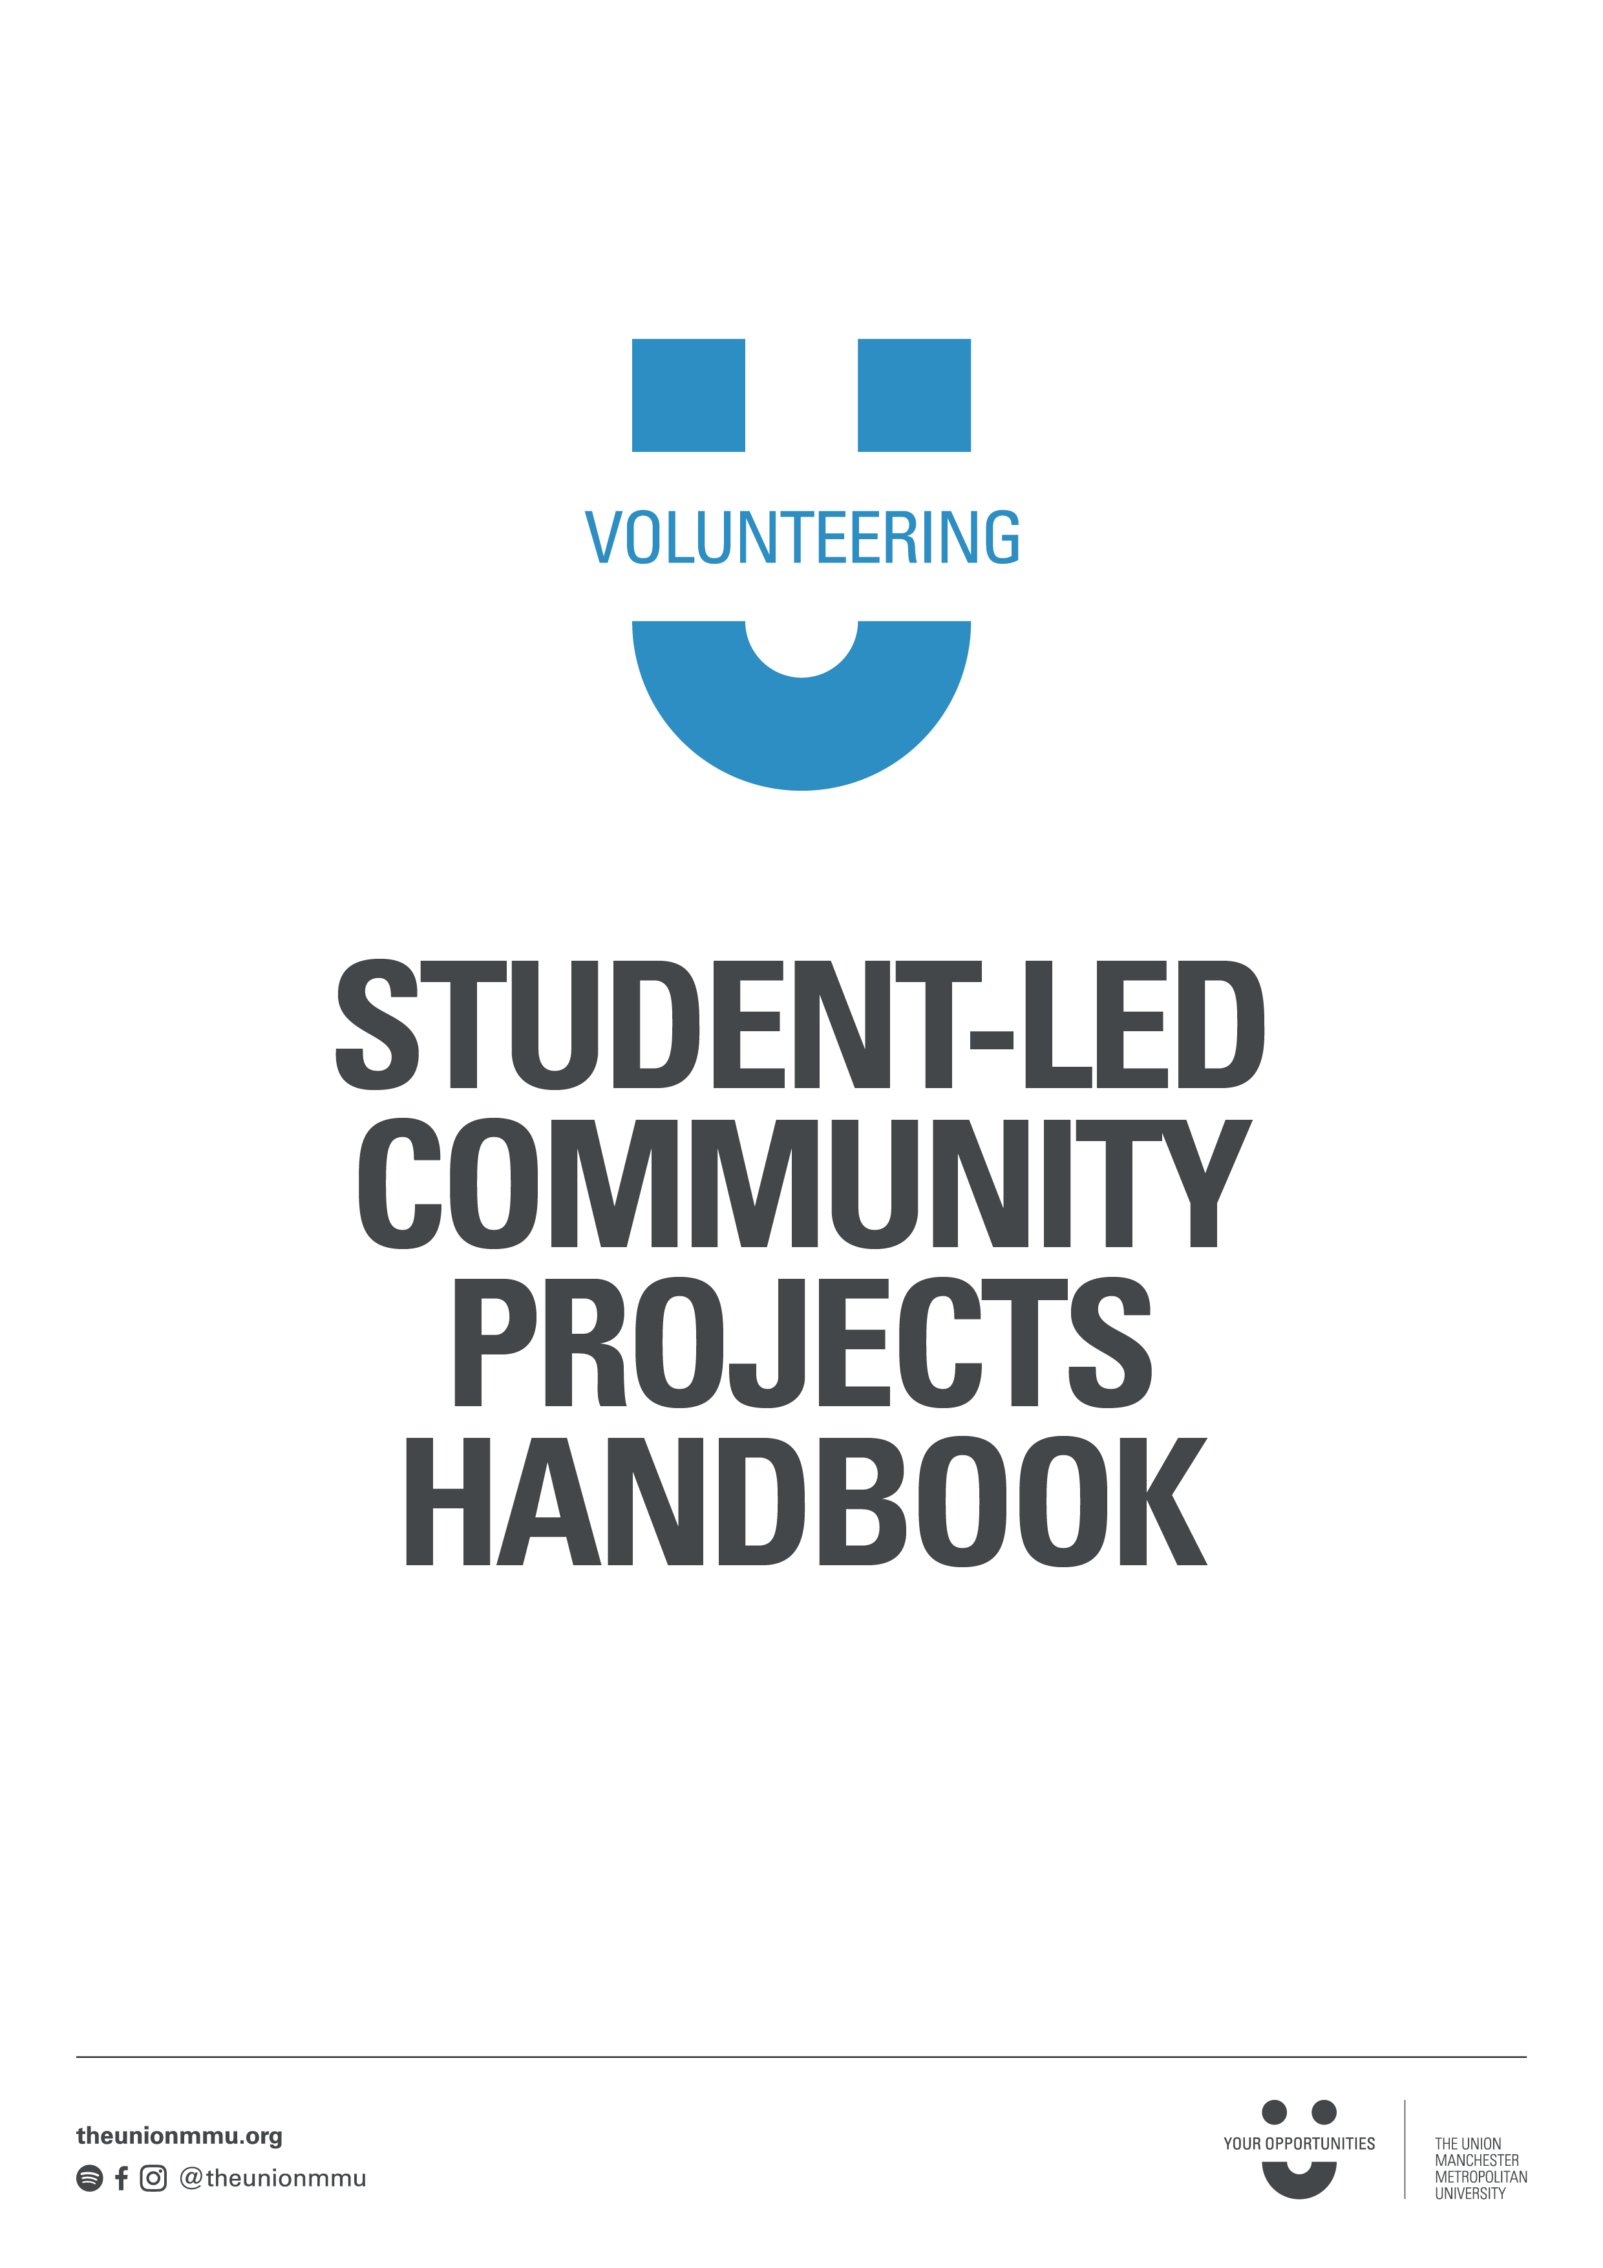

Contents
1. Introduction 3
How to use this toolkit? 3
What is the Student-led Community Project programme? 3
What can the programme offer you? 3
What is a Student-led Community Project? 3
What will you be doing as a project leader? 4
2. Time to think about your project! 5
What does your project need? 5
Step 1: Identifying your project 5
Step 2: Community Partners 8
Step 3: Aims, Outcomes and Objectives 8
Step 2: Preparing Your Project Plan 9
Step 3: SMART Goals 10
Step 4: Volunteer Recruitment 11
Step 5: Developing your communications 12
Step 6: Budget 12
Step 7: Risk Assessment 13
Step 8: Task List Timeline 17
Step 9: Evaluation planning 19
Step 10: Get in touch and set off!! 19

Introduction

How to use this toolkit?
This toolkit is a step- by- step guide in creating, planning and implementing your project with The Union. As well as a checklist, the toolkit also includes blank tool templates for you to fill in whilst planning and monitoring your project’s journey.

What is the Student-led Community Project programme?
Here at your Union, we understand that students really want to develop their skills and make a difference, however big or small that difference may be. The programme exists to help MMU students make this difference and learn the skills they need for life beyond university.

What can the programme offer you?
Leadership Opportunities – You’ll work with other students to run your own project.

Support – Every project has a dedicated member of staff from the Volunteering Team to provide advice and guidance throughout the entire project.

Training – You’ll have access to project leader training and other opportunities to develop your skills and knowledge.

Structure – We have the procedures in place to help you organise your project and ensure that it’s safe and well-run.

Recognition – You’ll have access to our volunteer reward and Recognition scheme

Progression – We can help you build upon your experiences as a project leader as you take your next steps

This toolkit, and The Union will support you in establishing the key goals and objectives that will ensure your project is a success.

What is a Student-led Community Project?
A community project benefits both students and residents in the local community; it brings together groups that might not interact otherwise and helps people to increase a sense of community. The project could be long term, short term or a one off event, and will always involve volunteers. The project will positively impact the local communities of Hulme, Fallowfield, Withington or Manchester City Centre and has to work with at least one of local council, local schools, charities, community groups, university students, local residents, community centres etc.

Your project will be lead primarily by you and your student team however the Volunteering Team are here to help and can:
- Look at your original project idea to see if it is feasible.
- Help you plan your project
- Meet with you regularly to offer advice and help
- Offer you building space within The Union
- Invite you to The Union’s training courses
- Provide funding for projects
- Suggest contacts with the local community and voluntary sector.
- Provide office facilities e.g. phones, cameras, digital recorder, laptop, scanner and
- photocopier.
- Help you publicise your project through our website, weekly newsletters, volunteer fairs etc

What will you be doing as a project leader?
- Writing a project plan
- Supporting with the recruitment of and managing and retaining volunteers
- Keeping in touch with your team members, and with your Volunteering Service Supervisor
- Supporting the training & induction for your volunteers
- Applying for funding
- Communicating with community organisations (e.g. charities)
- Completing the risk assessment for the project
- Ensuring health and safety guidance is followed
- Completing monthly activity logs
- Writing updates and providing photos for the Volunteering Service’s webpages
- Gathering monitoring data about your project and conducting an evaluation

Time to think about your project!

What does your project need?
- Research – Know your project. Why is it important?
- Aims and Objectives – You must be able to measure success and impact
- A Target Audience – Know who you want to be involved to achieve your objectives and who benefits from your project
- Publicity – How do you engage people in your project? Be creative!
- Planning – Your strategy should include timelines, activities, goals, and established roles
- A Reason – You are passionate about making a positive change in Manchester, you are passionate about a particular cause or charity, you are annoyed about something and wish to change it, or you wish to improve the lives of those around you
- Approval! - Your project must be approved as a Student-led Community Project before work can start on it.

Step 1: Identifying your project

It is important to identify the specific issue your project will focus on and be realistic in your aims. Focusing on an issue that is too broad can be setting your project up for failure. Think BIG but start small by narrowing the focus of your initial project idea. Your project will only grow in time giving you opportunity to make it even bigger and broader.

When you think you may have identified a project you’re passionate about, here are some things to consider:
- What will working on the issue accomplish?
- What is the likelihood of success?
- What is the severity of the issue?

If your project idea arose from an issue or problem you have identified in the local community it is important to establish the root causes of your issue, so you can understand where and how it is best to target the issue. This will also help to establish clear goals and objectives for your project.

The best tool to use here is The Problem Tree:
1: Write your problem in the middle of the page, alongside the tree trunk
2: At the bottom of the page, write down all of the causes of this problem. These are your root issues. Think about what is upholding this problem/allowing it to exist
3: Create your branches using the effects or consequences of your core problem or issue

Effects

Problem

Causes

Solution Tree:
Once you have completed your problem tree, you can then produce your solution tree: your project idea. This is simply a reversal of the problem tree. The core problem becomes your aim or goal, the causes become the solutions and the effects become the benefits.
For example:
Problem Tree, Core problem: Quality of air in Manchester is deteriorating
Solution Tree, Core Aim/Goal: Quality of air in Manchester is improved

Benefits

Solutions
Aim

Step 2: Community Partners
The process of identifying who will benefit from your project will be useful in finding potential partners – that is, organisations you can work with to help deliver your project. You may even have created your project idea with a specific charity or group in mind!

Potential partners include:
Community groups – e.g. the local playgroup
Charities and voluntary groups– e.g. a homeless shelter
Community support groups e.g. Manchester Student Homes
Schools
Local council

It is essential that you have one or more partners in the community.
Before you get in touch with anyone in the community or within MMU you must speak to the Volunteering Team first. There may be something important to tell you about that contact and we may already know someone there.

Step 3: Aims, Outcomes and Objectives
Once you have identified your issue, who the project involves and a broad aim it is important to clearly state what you’re trying to achieve, and how you’re going to do it. This is known as setting your Aim, Outcomes and Activities.

Your aim is the difference you want to make, simply summed up in a sentence. It should be something that you can realistically achieve, and should relate to the community need identified in your tree.

Your outcomes are what needs to change for you to achieve your aim.

Your activities are what you’ll need to do to bring about those outcomes

Aim
Outcomes

Activities

Step 2: Preparing Your Project Plan

This is the start of your project planning. In order to develop the most successful project you should use this time to think about what your project idea is, why you want to do this project, who you want to include in the planning and delivery, who benefits from the project, when the project takes place and how the project is implemented.
What?
Why? | Who? (and what) for? | When?
How?

Step 3: SMART Goals

It is important to create clear goals and objectives for your project. Goals and Objectives should be SMART:
Specific – objectives should specify exactly what you want to achieve.
Measurable – you should have measures by which you will be able to assess the degree of your success.
Achievable – objectives should be attainable and achievable.
Realistic – you need to ensure you have the resources available in order to meet your objectives.
Time-bound – you need to think about the timeframe you expect to meet your objectives in – have you set deadlines?

Goal = The project goal is the overall purpose of the project, why are you doing this project?
Objectives = specific acts that the project will do to contribute to achieving long-term success

Use this space to set yourself some SMART goals:
Goal:
Goal:

Goal:
Goal:

Step 4: Volunteer Recruitment
Volunteers are incredibly important to any Community Project. Volunteers, like yourself, are keen, engaged go-getters that want to help you make a difference! They can help you plan the project; coming up with ideas, contacting partners, finding venues etc. They can also help you deliver the project; on the day of the project, facilitating the project delivery etc.
The Union can help you recruit volunteers for your project through our volunteering portal, where we upload volunteer roles for all MMU students to access. We can promote roles through our newsletters and academic contacts to help you get the volunteers you need! If you have friends helping you on the project, make sure you let The Union know so that all volunteers can receive the support we provide.

Step 5: Developing your communications
A communications plan is vital for raising the profile of your project and mobilizing volunteers. A communications plan can include:
- Literature e.g. posters, leaflets etc.
- Social media e.g. platforms, videos, pictures, content, campaigns, takeovers etc.
- Word of mouth e.g. Lecture shout-outs, club/ societies council etc.
- Union wide marketing e.g. Volunteering portal, digital screens, website, blog posts etc.
The Union resources can really help at this stage; we are able to design marketing materials with you to a professional standard.

Step 6: Budget
Budget is always a really important element of any project to consider. The Union does have funding available for students wanting to do Student-Led Community projects that fit with our criteria! You will have to submit a budget breakdown to be awarded this.
Also, always think about what you might be able to borrow or gain from donations to reduce resource consumption and increase the profile of the project! For example, does The Union, the Uni or a Society already own the thing you’re looking to buy? Could you borrow it? Do you think a local business might want to donate items to you? Etc.
It’s important to budget for all resources before spending any money, and if you are receiving funding from The Union, always make sure that spends are approved with The Union prior to buying anything. Always keep hold of the receipt or online statement in order to be reimbursed!

Here is a breakdown tool to use for your budget:
Item | Justification  (why do you need to buy this?) | Price | QTY | Total cost

Step 7: Risk Assessment
Risk assessments are necessary for any project to ensure everyone involved in the project is always safe and happy. They’re not as daunting or complicated as they look, and The Union are always here to help you fill one in for your project should you need it. Your risk assessment should cover any possible risks throughout the project. It is probably a good idea to do an initial risk assessment for the planning and organisation of your project (Generic assessment) followed by another one for the project when it is up and running (Specific assessment).
Here is a template and step by step guide for your Risk Assessment:
ASSESSMENT UNDERTAKEN BY:
ASSESSMENT SIGNED OFF BY:
ASSESSMENT DATE:
X | 1 | 2 | 3 | 4 | 5
1 | 1 | 2 | 3 | 4 | 5
2 | 2 | 4 | 6 | 8 | 10
3 | 3 | 6 | 9 | 12 | 15
4 | 4 | 8 | 12 | 16 | 20
5 | 5 | 10 | 15 | 20 | 25
Stop
Urgent Action
Action
Monitor
No Action

How to calculate the Risk Class:
- First consider a risk e.g. slips, trips and falls
- Then consider the severity of that risk e.g. how much damage that risk has the capability of causing
- Assign the risk a severity rating from 1-5 based on the Severity key below
- Then consider the Likelihood of that risk occurring
- Assign the risk a likelihood rating from 1-5 based on the Likelihood key below
- Then times the Severity rating by the likelihood rating e.g. Severity 1x Likelihood 3 = Risk class 3. The number 3 is green on this chart therefore “no action” is needed.
- Then input this number into the Risk Class column of the risk assessment. If the Risk class yellow, orange or red you will need to do these calculations twice for each risk, once with current controls and once after further controls are implemented.

Key

Severity:

1 – Very little damage or danger, acceptable severity
2- Possible injury or damage but not severe e.g. Cuts. Bruises, damaged property
3 – Risks of reasonable injury or danger e.g. Broken bones
4 –Possibility of severe damage, injury, or long and short term health issues
5 – Possibility of fatal injury, more severe long term health issues or death

Likelihood:

1 –Not Likely at all
2 – Possibility of it happening
3 –Likely
4 –Very likely
5 – extremely likely if hazard occurs

Example Risk Assessment for a gardening project:
REF no. | Hazards & Risks | Persons at risk | Existing controls (what is already in place to mitigate risk?) | Risk class: Likelihood x Severity | Further Controls required (what else needs to be put in place to mitigate risk?) | Person(s) responsible | New *Risk class: Likelihood x Severity | Target completion date for Further Controls
1 | Slips, Trips and Falls | Volunteers and staff | There is a designated pathway for everybody to use. | 4 (monitor) | No action required: But will still encourage volunteers, and staff to wear suitable footwear with a good tread. | Volunteers and staff | 4 | Day of event

REF no.
Hazards & Risks
Persons at risk
Existing controls (what is already in place to mitigate risk?)
*Risk class: Likelihood x Severity
Further Controls required (what else needs to be put in place to mitigate risk?)
Person(s) responsible
New *Risk class: Likelihood x Severity
Target completion date for Further Controls

Step 8: Task List Timeline
It is important to create a task list for the project to ensure that everyone involved knows what they need to do, and by when. It also helps provide some clarity and structure to the project, and ensure that the crucial first steps of any project are completed in an efficient way.
Use this table to create a tasklist for your project, be as detailed as possible to help future you out!
Task
How long will it take?
Start
Deadline
Resources Required?
Who is responsible?
Task
How long will it take?
Start
Duration
(How long will it take)
Deadline
Who is responsible?

Step 9: Evaluation planning

Success is measured by evaluating your achievements against your original objectives set out at the very beginning of your campaign. It is important to remember that evaluation does not only happen right at the end of your campaign but should be continuous throughout, allowing you to adjust your tactics if needs be – this called monitoring.

To plan your evaluation, go back to your aim, outcomes and activities. Remember, these are the changes you’re planning to make, and what you’re going to do to bring about those changes. Then decide how you could measure them – your measurement tools. These could include:

- Handing out a short questionnaire after a session.
- Before-and-after surveys of participants to measure changes
- Sending an online survey to participants.
- Keeping track of easily counted aspects of your project – e.g. recording how many attendees turn up at each session.
- Having regular meetings with volunteers or your community partners to assess how well you are meeting your aim, outcome and activities.
- Holding a meeting with some of the beneficiaries to get their views.
- Having a suggestion box.
- Recording participants’ views with a video camera.
- Keeping a diary of your own reflections on the project.

Step 10: Get in touch and set off!!
You are ready to kick off your project! Enjoy all of your hard work and success, whichever form it takes. This journey will be exciting and revolutionary at times. You are part of the next cohort of leaders making a difference to Manchester and the wider world, embrace that and shout about it! Make sure you look after yourself, manage your time responsibly and make the most of support from The Union. Good luck!

